Grade: 2 OP -5
Date: The 28th of November
Theme: “We are one team – 25 years of Independence of the Republic of Kazakhstan.” (Мы одна команда – 25 лет Независимости РК)
Aims: 1. Educational: enrich student knowledge and vocabulary of the theme “Kazakhstan” , enable students to use the foreign language while speaking about their Motherland (обогатить свои знания и словарный запас по теме «Казахстан», уметь рассказать о своей Родине на иностранном языке); 2. Developmental: develop students reading, speaking and listening skills (развивать навыки чтения, говорения и аудирования); 3. Practical: erase students’ interest to the learning language by erasing the patriotic feeling to their Motherland (патриотически относиться к своей Родине).
Procedure of the lesson:
- Org. moment (2-3 min):
- Hello boys and girls! We are glad to see you! Hope that you had good weekends! Today we all will be working together. We have extracurricular lesson. Now look at the white board: (Presentation №1)
- Please, look at the blackboard, what do you see? What is the theme of our lesson? Let’s think all together, what are our aims of the lesson for today?
На доске развешаны иллюстрации, связанные с Казахстаном.
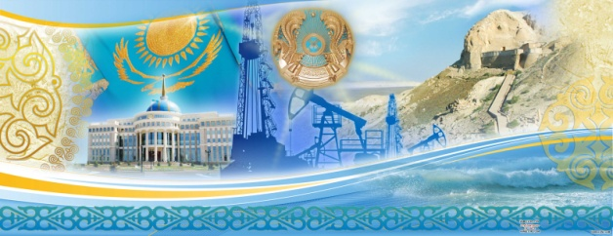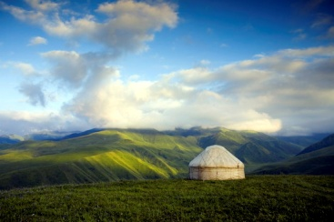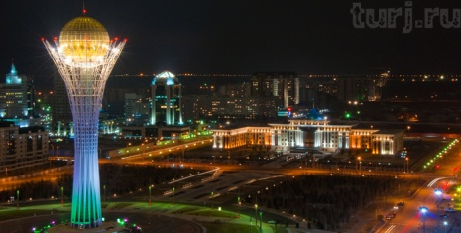

Warming up (2-3 min):
- Answer the questions Task 1. (orally)
1. What is the capital of Kazakhstan?
2. Who is a head of Kazakhstan?
3. How many people live there?
4. What are the largest lakes are there?
5. What can you say about climate of the Kazakhstan?
- Task 2. Odd and out (on the whiteboard)
In each line of words is one word which doesn’t go with other. Name this odd word and explain why is it odd?
1. Kazakhstan/ China/ India/ France
2. Tokyo/ Astana/ Ankara/ Spain
3. English/ Spanish/ Kazakh/ Great Britain
4. land/ continent/ country/ square
5. wheat/ millet/ corn/ border
Main part (25-30 min):
The class is divided into 4 groups – 6 persons, they should chose the captain and the speaker in each group, the rest will be helpers. – 2-3 min
Group 1 – STATISTICS DEPARTMENT
Group 2 – ENVIRONMENTAL DEPARTMENT
Group 3 – INDUSTRY AND AGRICULTURAL DEPARTMENT
Group 4 – CULTURAL DEPARTMENT
Task 1 Work over the vocabulary of the lesson (revision the main words, concerning the theme. Game “The bus station”) – 5-7 min
The words in English are given on the board, the words in Russian are on the table. The representeter from each group should come and chose the words on the table and match them with the words on the box. For each correct answer student get a sticker.
Situated – располагаться
Area – площадь
Population – население
Language – язык
Extend – протяженность
Border – граница
Depend – зависеть
River – река
Lake – озеро
Spring – весна
Autumn – осень
Summer – лето
Winter – зима
Grass – трава
Flower – цветок
Develop – развивать
Heavy industry – тяжелая промышленность
Agriculture – сельское хозяйство
Wheat – пшеница
Millet – просо
Corn – кукуруза
Cotton – хлопок
Anthem – гимн
Flag – флаг
Wings – крылья
Stripe – полоса
Hoist – край, держатель

Task 2. Make up a single bubble.
Each group is given the text which they should:
- Read
- Understand the meaning
- Make up a single bubble
- Present the information to the other groups
Kazakhstan
FOR THE STATISTICS DEPARTMENT
The Republic of Kazakhstan is situated in the Central Asia. The area of Kazakhstan is 2.753 000 square kilometers. Its population is about 17 million people. The population lives mostly in cities, towns or large villages. The largest cities are Almaty, Karaganda, Shimkent, Pavlodar and Astana. Astana is the capital of the country. Kazakh is the state official language of the country. But people also speak Russian, the language of national communication, and other.
Kazakhstan is the largest state in the Central Asia. It extends 1900 kilometers from the West to the East, and about 1300 kilometers from the North to the South. Kazakhstan borders China, Russia, Turkmenistan, Uzbekistan and Kirgizia. There is a long border coast line on the Caspian sea.
FOR THE ENVIRONMENTAL DEPARTMENT
There are rivers and lakes in Kazakhstan. The four rivers are the main water resource in the country. They are Irtish (in the East), Syrdarya (in the Southwest), Illi (in the Southeast) and Ural (in the Northwest). The largest lakes are Balhash, Zaisan, Ala – Kol and Tengis. The flora and fauna of the country are different. They depend on the climate of the area. They are richer in the South and poorer in the North.
The climate of the country is strongly continental. It is cold in winter and hot in summer. Rain usually falls in spring and autumn. Snow falls in all areas but not at the same time. In the South snow falls in October or November, in North – in September or October. Sudden cold winds and snowfalls in winter often cause troubles for people. In spring green grass and flowers cover lands and hills.
FOR THE INDUSTRIAL AND AGRICULTURAL DEPARTMENT
Kazakhstan has well – developed heavy industry in many cities. As the result the county suffers from environmental problems. Agriculture takes a very important sector in the national economy. The people grow wheat, millet, corn and cotton.
FOR THE CULTURAL DEPARTMENT
As an independent state Kazakhstan has its own national flag and anthem and national traditions and holidays. The national flag consists of a light blue field at the centre of which there is yellow sun framed by the wings of a flying eagle. There is a vertical stripe of national ornament near the hoist.

TIMING:
- Explanation of the task – 1-2 min
- Reading and decorating – 5-6 min
- Presentation -2-3 min * 4 groups

Task 3. Comprehension check. ( Students should answer the questions in groups in turns/ Студенты отвечают на вопросы по группам по очереди, заранее им раздаются таблички обозначающие ответы. Поднимая табличку они отвечают на вопросы.) Presentation 3
Test – 5-7 min

1.What is the capital of Kazakhstan?
a)Almaty b) Akmola c) Astana?

2.What is typical for Kazakhstan’s steppe?
a) tree b) saxaul c) pine-apple tree
3.Who is the head of the state?
a)President b) khan c) prime-minister
4.What is the population of Kazakhstan?
a)10 mln people b) 16 mln people c) 17 mln people
5.Where is Kazakhstan situated?
a) Europe b) Australia c) Central Asia
6. What is the climate of the state?
a) mild b) strongly continental c) continental
7. What is the national symbol of Kazakhstan?
a) the bald eagle b) the rose c) golden man
8. What is the area of Kazakhstan?
a) 1 546 000 square km b) 6 546 000 square km c) 2 753 000 square km
9. When is Nauryz celebrated?
a) in December b) in March c) in February
10. What lake is the Balkhash?
a) half fresh and half salty b) salty c) fresh
11. With what country doesn’t Kazakhstan share its border?
c) China d) Russia e) France
12. What is the largest city in Kazakhstan?
a) Astana b) Kokshetau c) Stepnоgorsk
13. What is typical animal of Kazakhstan?
a) snow leopard b) lion c) tiger
14. What is the state language in Kazakhstan?
a) Russian b) English c) Kazakh
15. For what have Kazakhs used falcons?
a) meat b) hunting c) playing
16. When is the Independence Day celebrated?
a) on the 16th of Dec. b) on the 22th of March c) on the 9th of May
17. What is the language of international communication?
a) English b) Kazakh c) Russian
18. What colour is the state flag?
a) blue and yellow b) blue and white c) red and yellow
19. “Astana” is the Kazakh word for:
a) population b) republic c) capital

20. Kazakhstan was established as the Republic of Kazakhstan in ……..:
a) December 1991 b) December 1997 c) November 1993

Reflection (3-5 min.)

